KV AFS YELAHANKA BANGALORE

COMPUTER SCIENCE INVESTIGATORY PROJECT

YALA FASHION

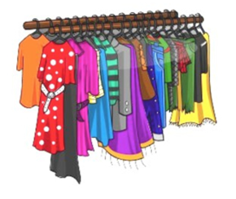HUB

UJWALA G

XI1 C

Roll no:



**CERTIFICATE**

This is to certify that UJWALA G of class XII C, Kendriya Vidyalaya, AFS, Yelahanka, Bangalore-63, session 2016-2017, has satisfactorily completed Computer Science Investigatory Project titled “YALA FASHION HUB”.

External Examiner Internal Examiner

(Mr. Goverdhan Satish K.V., PGT CS)

Principal Date:

(Mr. Y G Patil)

**ACKNOWLEDGEMENT**

I would like to thank Principal,

Mr. Y.G PATIL, Kendriya Vidyalaya AFS, Yelahanka, Bengaluru-63, for providing all the necessary facilities for completing the project in time.

I would like to show my gratitude towards my Computer Science Teacher,

Mr. Goverdhan Satish K.V, PGT CS, who guided me in processing this project.

I would like to express my gratitude to my parents their constant support and encouragement.

**INDEX**

|  |  |
| --- | --- |
| SL.NO. | CONTENTS |
|  | Certificate |
|  | Acknowledgement |
|  | Synopsis |
|  | Interview |
|  | Group Members |
|  | Introduction |
|  | System Analysis |
|  | Data Flow Diagram |
|  | Coding |
|  | Testing |
|  | Documentation |
|  | Conclusions |
|  | Future Updating |
|  | Bibliography |

**SYNOPSIS**

**Whenever we want to buy clothes, we visit apparel showrooms/ fashion stores. Shopkeepers display/ showcase their clothes so that we can buy them.**

**The project is implemented using**

* **C++ as front end**
* **Text file as back end**

**YALA FASHION HUB program is designed to simplify mangers’ job of maintaining records of customers, clothes available in the showroom and clothes sold in a particular month.**

**The user interface helps the user to administer all the details of the showroom. Two external files (.txt) are used to store the details of clothes and buyers.**

**INTERVIEW**

**To know the problems faced by managers of fashion stores /apparel showrooms, we conducted an interview. We enquired about shop management including stock and customer management. This was to ensure that we understood their problems and try to reduce their workload by creating a program.**

**Questions asked:**

1. **Since how long have you been in this profession? What qualities do you look for in a salesperson?**

**A. For almost 5 years. A salesperson should be pleasing, agile and should be smart enough to understand the needs of the customer.**

1. **How do you manage your showroom/store?**

**A. We arrange the clothes gender and style wise. As per the customer‘s need, we show the clothes.**

1. **What are the details that a customer wishes to know before purchasing?**

**A. A customer wants to know if the dress which he/she wants is available in his/her size and desired colour. If unsatisfied he/she asks for other designs. Sometimes he/she fixes a price range for selection of clothes.**

1. **How do you help customers in selecting their desired apparel?**

**A. We assure them that our products are of the best quality, in both material and stitching. We suggest clothes according to their budget. Once our salesperson understands the customers’ choice he/she assures them that it suits them the best.**

1. **How do you manage to keep records of so many customers?**

**A. We use bill books with a carbon copy which are stored.**

1. **How do you keep account of such a large variety of clothes?**

**A. We have a monthly stock checking, which is a very tedious job. Sometimes, we even close our shop for this purpose. Mistakes still happen. Because of this, we have to return many customers as we do not have the size they ask for.**

**CONTRIBUTION OF GROUP MEMBERS**

|  |  |  |
| --- | --- | --- |
| Group Member Name | Contribution | Time Taken  (in hrs) |
| Ujwala .G | 1. Giving ideas for program. | 2 |
| 2. Typed 1/2 of the program. | 8 |
| 3. Made report of program. | 5.5 |
| 4. Made video for presentation | 2 |
| 5. Entered data for program. | 4 |
| 6. Took screenshots | 1 |
| 7. Interview | 2 |
| 8. Demo in class | 0.5 |
|  | | Total : 25 |

|  |  |  |
| --- | --- | --- |
| Group Member Name | Contribution | Time Taken  (in hrs) |
| Siya Philip | 1. Giving ideas for program. | 2 |
| 2. Typed 1/2 of the program. | 8 |
| 3. Made report of program. | 5.5 |
| 4. Made video for presentation | 2 |
| 5. Entered data for program. | 4 |
| 6. Took screenshots | 1 |
| 7. Interview | 2 |
| 8. Demo in class | 0.5 |
|  | | Total : 25 |

**INTRODUCTION**

**The basic requirements of human beings for their survival are food, shelter and clothing. People should be able to exercise their choice and wear all kinds of clothes. For simplicity or to make a fashion statement or just follow a fashion trend.**

**With the increase in population, the demand for clothing is also increasing. Due to globalisation and advances in fashion technology, the variety of clothes has also increased. The urge of being up-to-date is driving people to try out various types of clothes.**

**As shops have various types of clothes in various colours, various sizes, various styles and various brands, it is difficult for human brain to keep record of them. Shops require to store every detail about their stock and also about their customers.**

**We have made a program through which we can analyse the sales on a day-to-day basis thus helping us to stock clothes which are in demand, lessening the manual burden of the person in-charge.**

**SYSTEM ANALYSIS**

**Specification required for new systems**

|  |  |
| --- | --- |
| **Operating System** | **MS Windows 7 /8/8.1/10** |
| **Computer** | **Intel Pentium III or IV/ AMD Athlon or Higher ; 1.7GHz , 512 MB RAM** |
| **Hardware** | **0-250 Gb hard-drive, Keyboard, Monitor** |
| **System Specifications** | **ANSI C++** |

**SYSTEM TESTING:**

**The system was tested several times. Some minor errors were reported and corrected on time. The system failure was not reported. The system worked well. Now this program is free of errors and the probability of crashing is nil.**

**CODING**

#include<iostream.h>

#include<string.h>

#include<fstream.h>

#include<conio.h>

#include<process.h>

#include<stdio.h>

#include<stdlib.h>

using namespace std;

class clothes

{

char brand[20],model[20],size[10],colour[20],mat[20],cat[10],

type[20];

int price,avail;

public:

void read()

{

cout<<"\n enter the category: ";

cin>>cat;

cout<<"\n enter the type: ";

cin>>type;

cout<<"\n enter brand name:";

cin>>brand;

cout<<"\n enter model : ";

cin>>model;

cout<<"\n enter price:";

cin>>price;

cout<<"\n enter size :";

cin>>size;

cout<<"\n enter colour :";

cin>>colour;

cout<<"\n enter cloth material :";

cin>>mat;

cout<<"\n enter availibility :";

cin>>avail;

}

void display()

{

cout<<"\n"<<brand<<"\t"<<model<<"\tRs"<<price<<"\t"<<size<<"\t"<<colour<<"\t"<<mat<<"\t"<<avail<<" available";

}

char* getbr()

{

return brand;

}

char* getsize()

{

return size;

}

char* getcol()

{

return colour;

}

char* getmat()

{

return mat;

}

int getpr()

{

return price;

}

char* getmod()

{

return model;

}

void decavail()

{

avail--;

}

char* getcat()

{

return cat;

}

char* gettype()

{

return type;

}

int getavail()

{

return avail;

}

void maindisp()

{

cout<<"\n"<<type<<"\t"<<brand<<"\t"<<model<<"\tRs"<<price<<"\t"<<size<<"\t"<<colour<<"\t"<<mat<<"\t"<<avail<<" available";

}

};

class details

{

char name[30], add[50],phn[20],modbuy[20],typebuy[20],catbuy[20],

brbuy[20];

int rate;

public:

void read(int amt,char buytype[20],char buycat[20],char buymod[20],char buybr[20])

{

cout<<"\n enter name: ";

cin>>name;

cout<<"\n enter address: ";

cin>>add;

cout<<"\n enter phone no.: ";

cin>>phn;

strcpy(modbuy,buymod);

rate=amt;

strcpy(typebuy,buytype);

strcpy(catbuy,buycat);

strcpy(brbuy,buybr);

}

void display()

{

cout<<"\n\n name: ";

cout<<name;

cout<<"\n address: ";

cout<<add;

cout<<"\n phone no.: ";

cout<<phn;

cout<<"\n type bought: ";

cout<<typebuy;

cout<<"\n model bought: ";

cout<<modbuy;

cout<<"\n amount paid : ";

cout<<rate;

}

int getrate()

{

return rate;

}

char * getmod()

{

return modbuy;

}

char* getcat()

{

return catbuy;

}

char* gettype()

{

return typebuy;

}

char* getbr()

{

return brbuy;

}

void disname()

{

cout<<"\n"<<name;

}

char* getname()

{

return name;

}

};

void disptype()

{

cout<<"\n------------ TYPES AVAILABLE AT YALA -----------------------------------------";

cout<<"\n\n pants\t t_shirt\t shirt\t jacket\t shorts\t skirt\t top\t jumpsuit\t dress\t palazzos\t kurtis\t dungrees\t sarees\t anarkali\t frock";

cout<<"\n------------------------------------------------------------------------------";

}

void dispbrand()

{

cout<<"\n------------- BRANDS AVAILABLE AT YALA----------------------------------------";

cout<<"\n\n wrangler\t pepe_jeans\t indigo_nation\t lee_cooper\t buffalo\t bare\t flying_machine\t proline\t scullers\t urbana\t mark_taylor\t mother_earth\t jealous21\t rig\t ethnicity\t raymond\t fitz\t srishti\t colors\t gini&jony\t ant\t seals\t diesel\t chloe\t gucci\t d&g\t only\t vera_moda\t vanheusen\t levis\t fcuk\t rimmel\t biba\t lee\t puma\t arrow\t and\t global_desi\t being_human\t allen_solly\t holii";

cout<<"\n------------------------------------------------------------------------------";

}

int main()

{

clothes c;

details d;

ifstream fin;

ofstream fout;

int ch,i,entry,count;

char cont,purch,pass[20],any;

char catsold[20],typesold[20],brsold[20];

unsigned long total=0;

system("cls");

cout<<"\n*********************************************************************";

cout<<"\n\t\t\t YALA FASHION HUB";

cout<<"\n*********************************************************************";

cout<<"\n\t\t\t A Project by\n\t\t Ujwala G and Siya Philip \n\t\t\t Class XII C\n\t\t Kendriya Vidyalaya AFS Yelahanka";

cout<<"\n*********************************************************************";

cout<<"\n\n Enter any key to continue....";

cin>>any;

system("cls");

cout<<"\n********************** YALA FASHION HUB *****************************";

cout<<"\n\n YOU ARE.....\n\t1. ADMINISTRATOR\n\t2. CUSTOMER\nOTHERWISE 10. EXIT\n ENTER CHOICE: ";

cin>>entry;

system("cls");

switch(entry)

{

case 1: //admin

cout<<"\n enter password:";

cin>>pass;

if(strcmp(pass,"siya_ujwala")!=0)

return(0);

do{

system("cls");

cout<<"\n*******************************

*****************************";

cout<<"\n 1. add new detail \n 2. display the details \n 3. buyers list \n 4. total income \n 5. items sold\n 6. modify record \n 10. exit ";

cout<<"\n************************************************************\n";

cout<<"enter the choice : ";

cin>>ch;

switch(ch)

{

case 1:

fout.open("f:\\clothes.txt",ios::app|ios::binary);

c.read();

fout.write((char*)&c,sizeof(c));

fout.close();

break;

case 2:

int choice; char cats[20],types[20];

cout<<"\n\t1. display by category\n\t2. display by category and type\n enter choice: ";

cin>>choice;

switch(choice)

{

case 1:

cout<<"\n enter the category: ";

cin>>cats;

fin.open("f:\\clothes.txt",ios::in|ios::binary);

while(fin.read((char*)&c,sizeof(c)))

{ if(strcmp(c.getcat(),cats)==0 )

c.maindisp();

}

fin.close();

break;

case 2:

cout<<"\n enter the category: ";

cin>>cats;

cout<<"\n enter the type: ";

cin>>types;

fin.open("f:\\clothes.txt",ios::in|ios::binary);

while(fin.read((char*)&c,sizeof(c)))

{

if((strcmp(c.gettype(),types)==0)&&(strcmp(c.getcat(),cats)==0 ))

c.display();

}

fin.close();

break;

}

break;

case 3:

fin.open("f:\\details.txt",ios::in|ios::binary);

while(fin.read((char*)&d,sizeof(d)))

{

d.display();

}

fin.close();

break;

case 4:

fin.open("f:\\details.txt",ios::in|ios::binary);

while(fin.read((char*)&d,sizeof(d)))

{

total+=d.getrate();

}

cout<<"\n TOTAL INCOME : Rs. "<<total;

fin.close();

break;

case 5:

count=0;

cout<<"\n enter category: ";

cin>>catsold;

cout<<"\n enter type: ";

cin>>typesold;

cout<<"\n sold brands : ";

fin.open("f:\\details.txt",ios::in|ios::binary);

while(fin.read((char*)&d,sizeof(d)))

{

if((strcmp(d.gettype(),typesold)==0)

&&(strcmp(d.getcat(),catsold)==0 ))

{ count++;

cout<<"\t " <<d.getbr();

}

}

cout<<"\n TOTAL SOLD: "<<count;

cout<<"\n............................................

........................";

fin.close();

char chco;

cout<<"\n do you want to check brand-wise(y/n) ? ";

cin>>chco;

if(chco=='y')

do

{ count=0;

cout<<"\n enter brand : ";

cin>>brsold;

fin.open("f:\\details.txt",ios::in|ios::binary);

while(fin.read((char*)&d,sizeof(d)))

{

if((strcmp(d.getbr(),brsold)==0))

{ count++;

}

}

cout<<"\n TOTAL SOLD: "<<count;

cout<<"\n do you want to search more brands (y/n)? ";

cin>>chco;

}while(chco=='y');

break;

case 6:

char mod2[20];

clothes c2;

cout<<"\nmodel no present in the file...\n";

fin.open("f:\\clothes.txt",ios::in|ios::binary);

while(fin.read((char *)&c,sizeof(c)))

{

cout<<"\t"<<c.getmod();

}

fin.close();

cout<<"\nenter model no to be modified: ";

cin>>mod2;

cout<<"\nenter new details: ";

c2.read();

fin.open("f:\\clothes.txt",ios::in|ios::binary);

fout.open("f:\\tem.txt",ios::app|ios::binary);

while(fin.read((char *)&c,sizeof(c)))

{

if(strcmp(mod2,c.getmod())==0)

fout.write((char*)&c2,sizeof(c2));

else

fout.write((char*)&c,sizeof(c));

}

fout.close();

fin.close();

remove("f:\\clothes.txt");

rename("f:\\tem.txt","f:\\clothes.txt");

break;

default:

return(0);

}

cout<<"\n do you want to continue(y/n)?" ;

cin>>cont;

}while(cont=='y');

break;

case 2: //customer

for(;;){

char chcat[20],chtype[20];

system("cls");

cout<<"\n WHICH SECTION DO YOU WANT TO PURCHASE FROM?\n\t* ladies\n\t* gents\n\t* kids\n otherwise \n\t exit\n ENTER CHOICE: ";

cin>>chcat;

if(strcmp(chcat,"exit")==0)

{

return(0);

}

disptype();

cout<<"\n ENTER THE TYPE: ";

cin>>chtype;

do{

system("cls");

cout<<"\n "<<chcat<<"\t"<<chtype;

cout<<"\n***********************************************

*************";

cout<<"\n 1. display all\n 2. choose by brand \n 3. choose by price\n 4. choose by size\n 5. choose by colour\n 6. choose by cloth material\n 7. exit ";

cout<<"\n**********************************************

**************\n";

cout<<"\n enter choice :";

cin>>ch;

switch(ch)

{

case 1: count=0;

fin.open("f:\\clothes.txt",ios::in|ios::binary);

while(fin.read((char*)&c,sizeof(c)))

{ if((strcmp(c.gettype(),chtype)==0)

&&(strcmp(c.getcat(),chcat)==0 ))

{ c.display();

count++;

}

}

cout<<"\n"<<count<<" option(s) found";

fin.close();

break;

case 2: char chbr[20];

count=0;

dispbrand();

cout<<"\n enter choice brand: ";

cin>>chbr;

fin.open("f:\\clothes.txt",ios::in|ios::binary);

while(fin.read((char*)&c,sizeof(c)))

{ if((strcmp(c.gettype(),chtype)==0)

&&(strcmp(c.getcat(),chcat)==0 ))

if(strcmp(chbr,c.getbr())==0)

{ c.display();

count++;

}

}

cout<<"\n"<<count<<" option(s) found";

fin.close();

break;

case 3:

int chpr;

count=0;

cout<<"\n range options\n\t1.below 500\n\t2.between 500 & 1000\n\t3.between 1000 & 2000\n\t4.above 2000:";

cout<<"\n enter choice:";

cin>>chpr;

fin.open("f:\\clothes.txt",ios::in|ios::binary);

while(fin.read((char*)&c,sizeof(c)))

{ if((strcmp(c.gettype(),chtype)==0)

&&(strcmp(c.getcat(),chcat)==0 ))

switch(chpr)

{

case 1:

if(c.getpr()<=500)

{ c.display();

count++;

}

break;

case 2:

if(c.getpr()>500&&c.getpr()<=1000)

{ c.display();

count++;

}

break;

case 3:

if(c.getpr()>1000&&c.getpr()<=2000)

{ c.display();

count++;

}

break;

case 4:

if(c.getpr()>2000)

{ c.display();

count++;

}

break;

default:

cout<<"\nplease enter properly..";

break;

}

}

cout<<"\n"<<count<<" option(s) found";

fin.close();

break;

case 4:

char chsize[10];

count=0;

cout<<"\n size options \n\t S: small \n\t M: medium \n\t L: large \n\t XL: extra large ";

cout<<"\n enter choice: ";

cin>>chsize;

fin.open("f:\\clothes.txt",ios::in|ios::binary);

while(fin.read((char*)&c,sizeof(c)))

{ if((strcmp(c.gettype(),chtype)==0)

&&(strcmp(c.getcat(),chcat)==0 ))

if(strcmp(chsize,c.getsize())==0)

{ c.display();

count++;

}

}

cout<<"\n"<<count<<" option(s) found";

fin.close();

break;

case 5: char chcol[20];

count=0;

cout<<"\n enter choice colour: ";

cin>>chcol;

fin.open("f:\\clothes.txt",ios::in|ios::binary);

while(fin.read((char*)&c,sizeof(c)))

{ if((strcmp(c.gettype(),chtype)==0)

&&(strcmp(c.getcat(),chcat)==0 ))

if(strcmp(chcol,c.getcol())==0)

{ c.display();

count++;

}

}

cout<<"\n"<<count<<" option(s) found";

fin.close();

break;

case 6: char chmat[20];

count=0;

cout<<"\n enter choice cloth material: ";

cin>>chmat;

fin.open("f:\\clothes.txt",ios::in|ios::binary);

while(fin.read((char*)&c,sizeof(c)))

{ if((strcmp(c.gettype(),chtype)==0)

&&(strcmp(c.getcat(),chcat)==0 ))

if(strcmp(chmat,c.getmat())==0)

{ c.display();

count++;

}

}

cout<<"\n"<<count<<" option(s) found";

fin.close();

break;

default:

return(0);

}

cout<<"\n DO YOU WANT TO BUY(Y/N)?";

cin>>purch;

if(purch=='Y'&& count!=0)

{ int amt;

char buytype[20],buycat[20],buybr[20];

char modch[20];

cout<<"\n To check if available, enter the model: ";

cin>>modch;

//retrieving data

fin.open("f:\\clothes.txt",ios::in|ios::binary);

while(fin.read((char*)&c,sizeof(c)))

{

if(strcmp(modch,c.getmod())==0)

{

amt=c.getpr();

strcpy(buytype,c.gettype());

strcpy(buycat,c.getcat());

strcpy(buybr,c.getbr());

}

}

fin.close();

//reducing availability

fin.open("f:\\clothes.txt",ios::in|ios::binary);

fout.open("f:\\avail.txt",ios::app|ios::binary); while(fin.read((char *)&c,sizeof(c)))

{

if(strcmp(modch,c.getmod())==0)

{

c.decavail();

fout.write((char*)&c,sizeof(c));

}

else

fout.write((char*)&c,sizeof(c));

}

fout.close();

fin.close();

remove("f:\\clothes.txt");

rename("f:\\avail.txt","f:\\clothes.txt");

//deleting if avail=0

fin.open("f:\\clothes.txt",ios::in|ios::binary);

fout.open("f:\\avail.txt",ios::app|ios::binary); while(fin.read((char *)&c,sizeof(c)))

{

if(c.getavail()!=0)

fout.write((char*)&c,sizeof(c));

}

fout.close();

fin.close();

remove("f:\\clothes.txt");

rename("f:\\avail.txt","f:\\clothes.txt");

//storing details

cout<<"\n enter your details ( please don't use spaces after each word, use UNDERSCORE):";

fout.open("f:\\details.txt",ios::app|ios::binary);

d.read(amt,buytype,buycat,modch,buybr);

fout.write((char*)&d,sizeof(d));

fout.close();

system("cls");

cout<<"\n\nTHANK YOU FOR PURCHASING....PURCHASE SUCCESSFUL.....";

cout<<"\n\nenter any alphabet to continue.....";

cin>>any;

break;

}

else

{

cout<<"\n do you want to continue in this category(y/n)?" ;

cin>>cont;

}

}while(cont=='y');

}//for infinite loop

default:

return(0);

}

}

**TESTING**

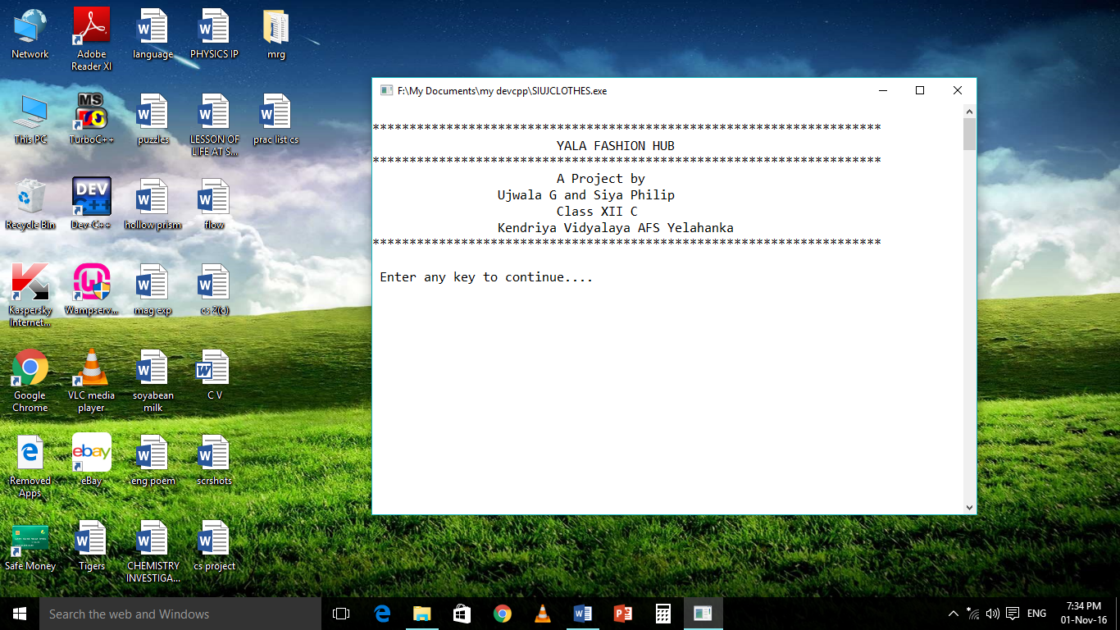

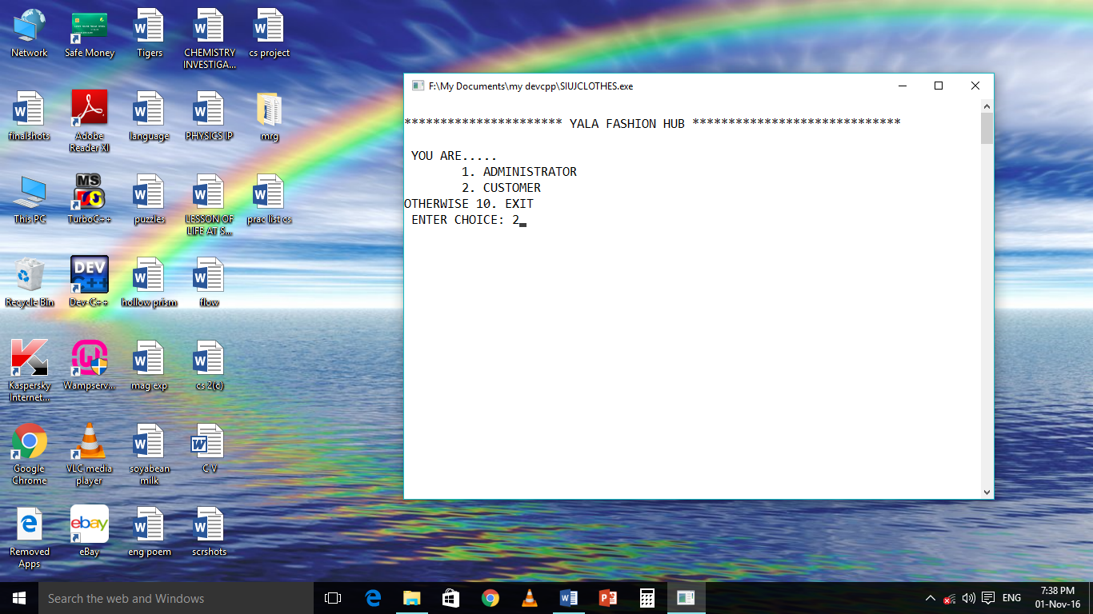

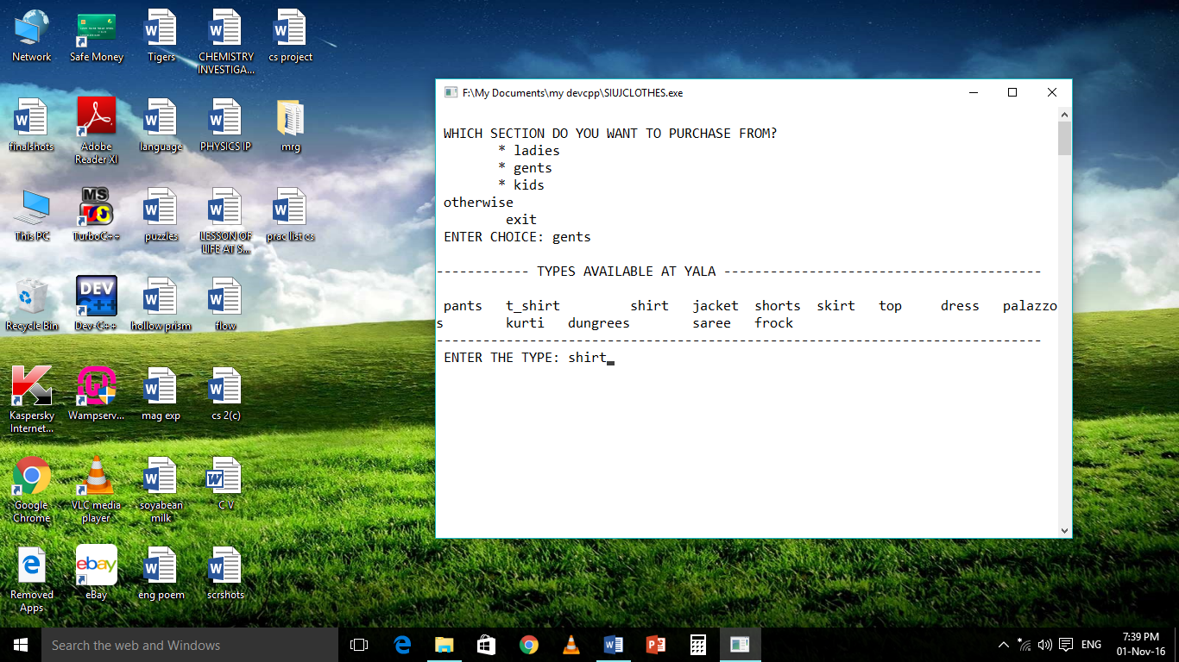

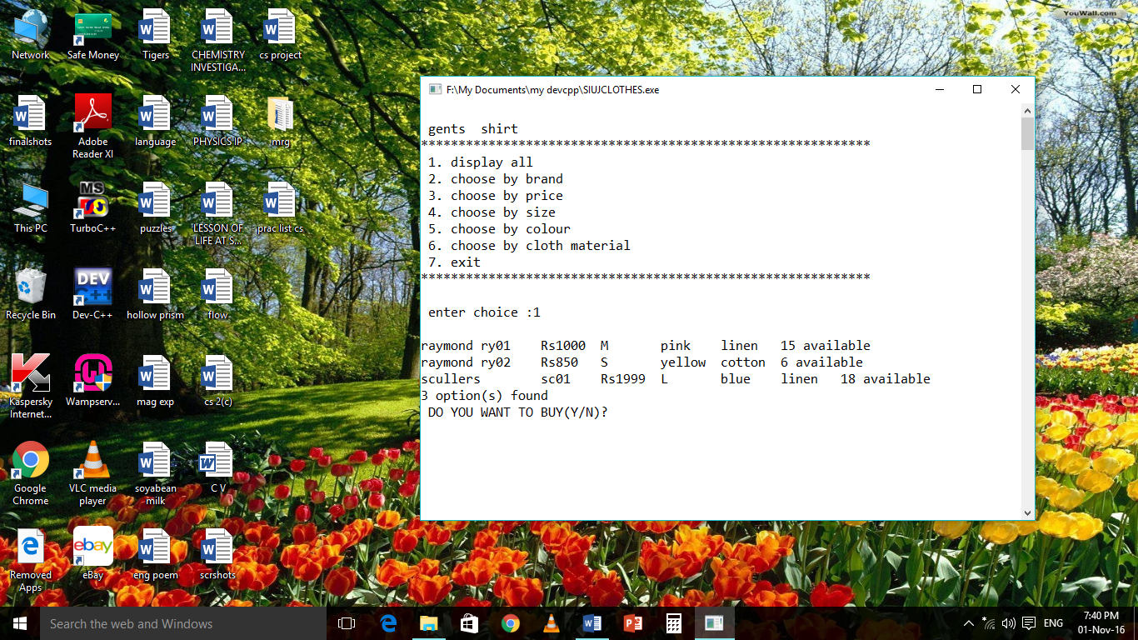

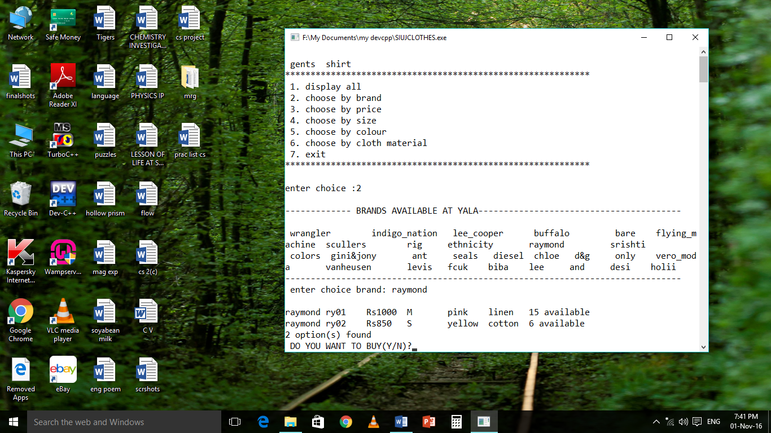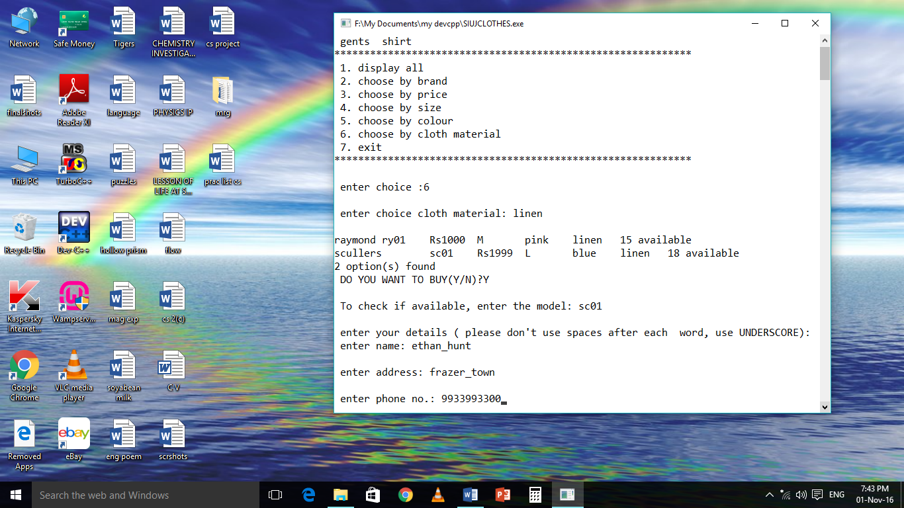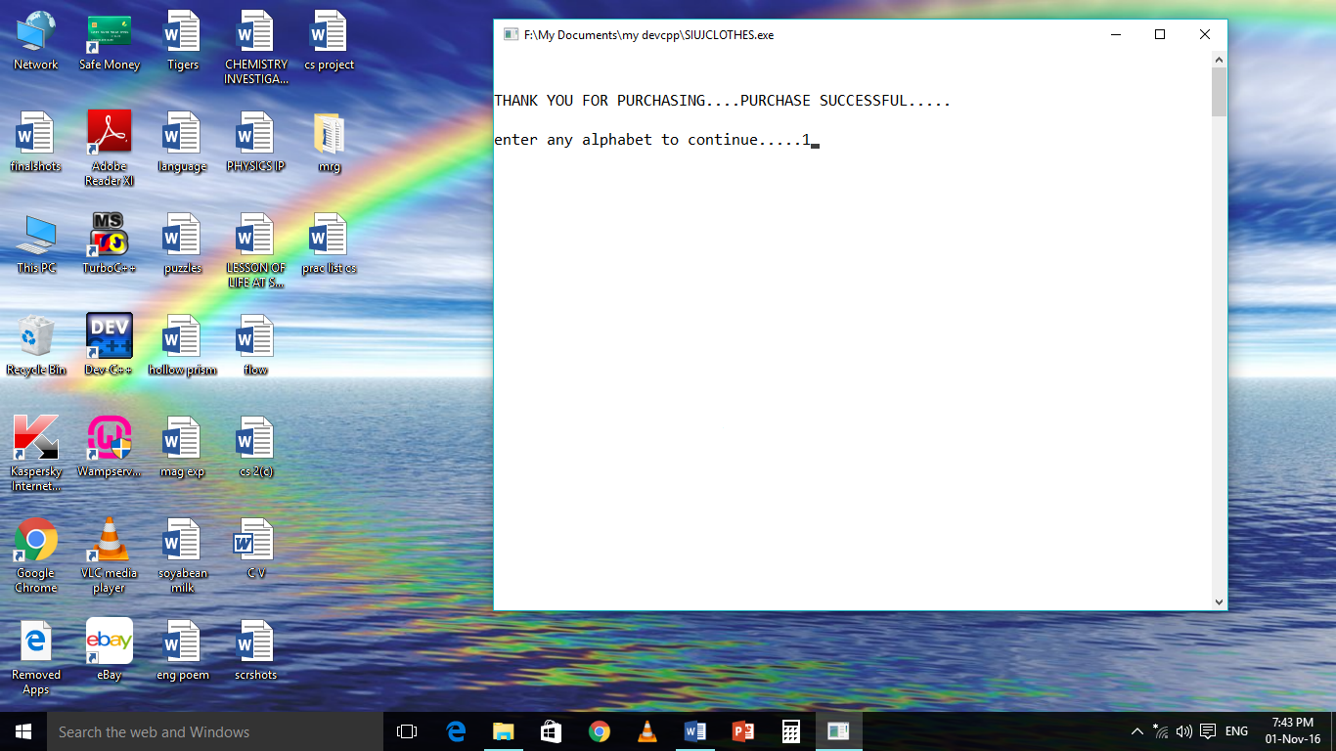

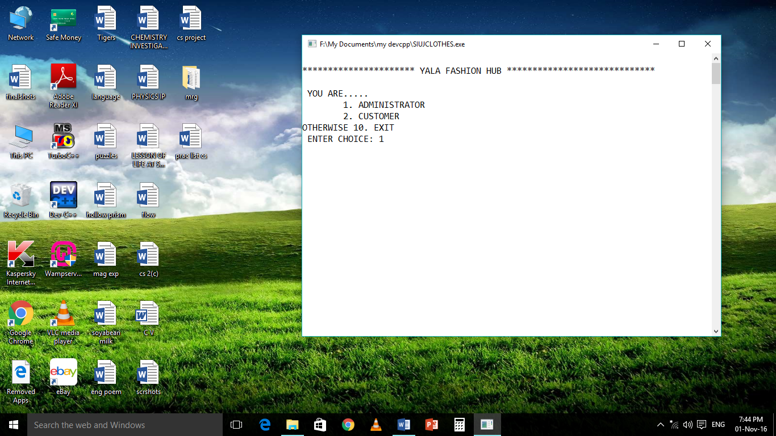

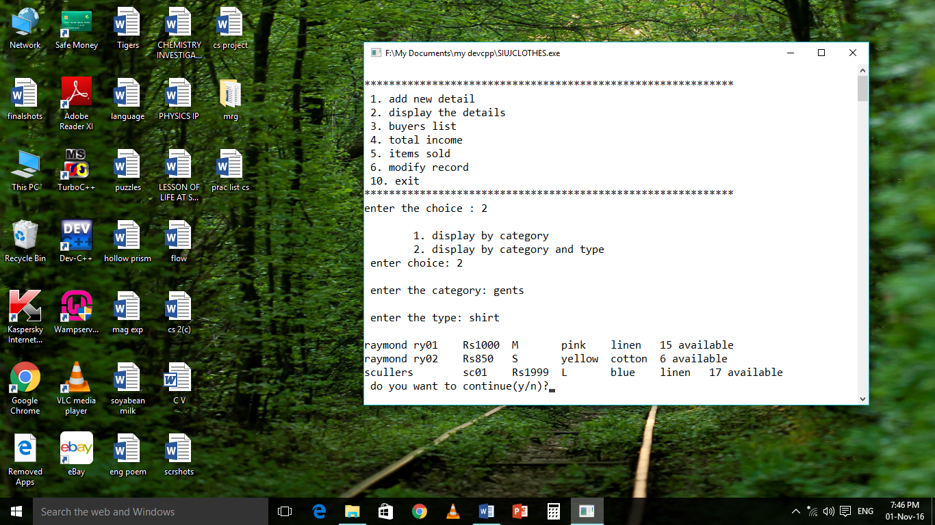

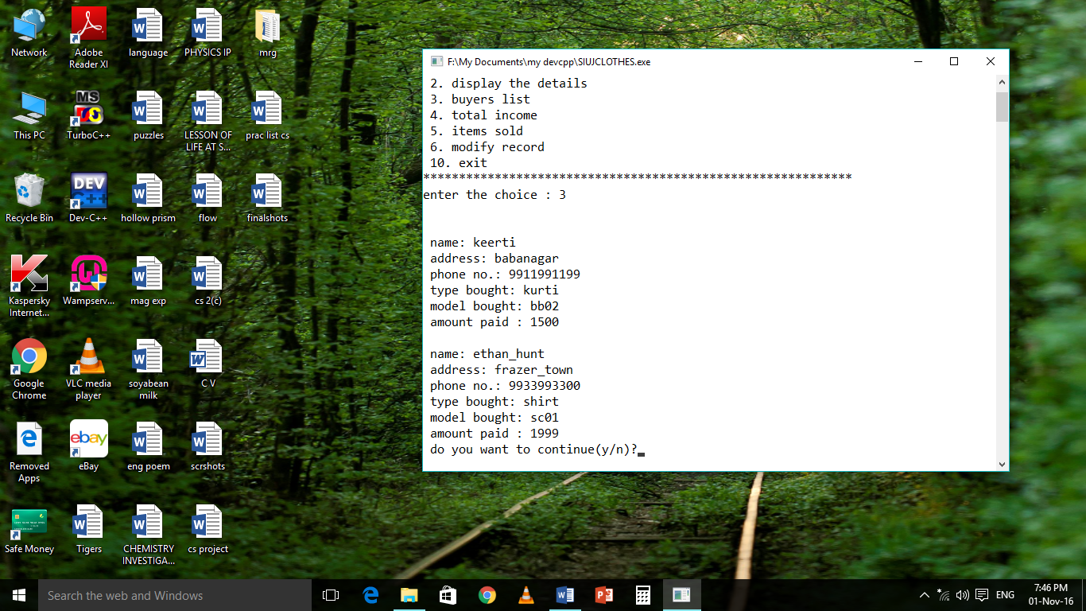

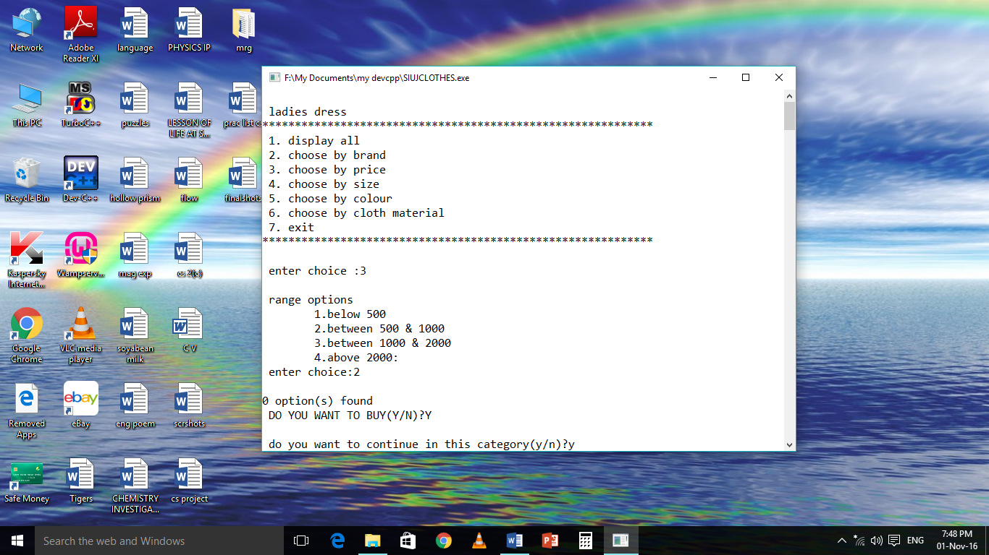

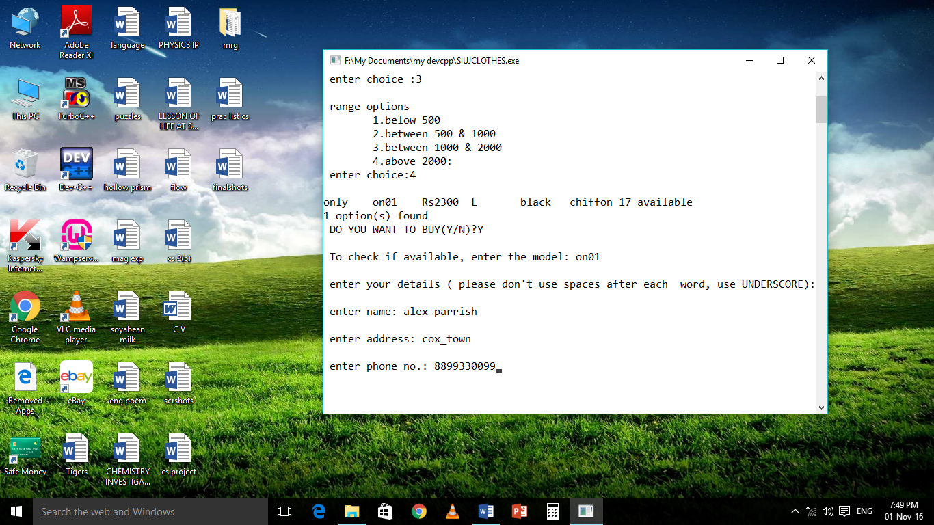

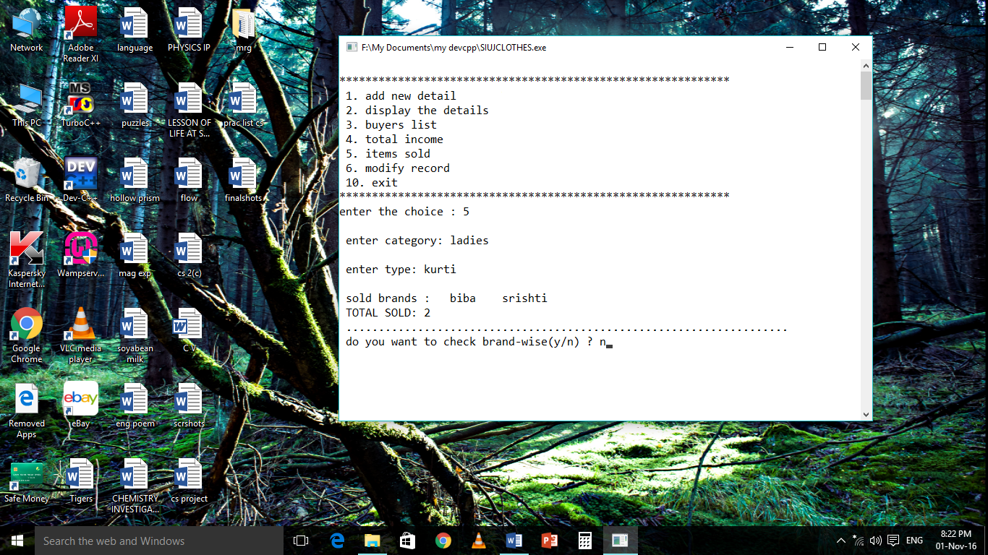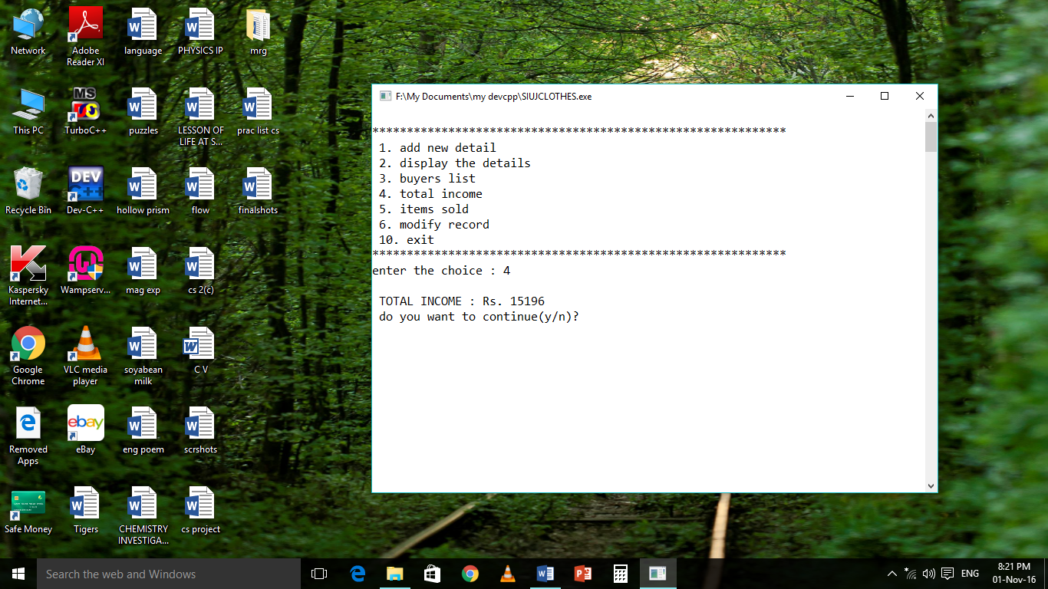

**CONCLUSIONS**

**The project titled ‘YALA FASHION HUB’ is able to perform all the operations in a fast and effective way. It can do operations like storing product details, buyers details, and other location details and it can be used to read the stored details as well as the details can also be updated. So these types of program reduce the stress on human beings. This project is running successfully and free of errors.**

**DOCUMENTATION**

**To login as administrator use password “siya_ujwala”. Enter choice as required. For example, if we choose display the details it will ask for category. We can type ladies, gents or kids. When it will ask for type, enter pants, shirt, top etc.**

**When we have to modify a record, model numbers will be displayed. We have to enter desired model number. Then we have to enter the new details.**

**For customers, type the category (ladies, gents or kids) and then the type (pants, shirt, top etc.). We can choose by brand, price range, size, colour or by material. When we have finalized on a product, enter model number to check for its availability. Then we have to enter the customer’s details (name, address and phone number) and the purchase is successful.**

**FUTURE UPDATING**

1. **To display the list of customers who got their delivery.**
2. **To show the list admin persons in the buyers.**

**EXAMPLE**

**OUTPUT:**

**Siya ADMIN (Then her details)**

**Ujwala ADMIN (Then her details)**

**And for others (who is not admin) directly shows their details.**

1. **To solve the problem of case sensitivity.**

**BIBLIOGRAPHY**

* **Computer science with C++**

**by Sumita Arora ( class XII)**